At Buronga Public School we are very excited about our new resources in the playground. Our sandpit is very popular and I have observed many students of all ages engaged in positive play where it is obvious that students are not only enjoying the experience, but developing valuable interpersonal and interactive skills. Providing opportunities for students to be actively engaged in valuable and enjoyable learning experiences in the playground is an ongoing commitment at Buronga.
19/10/ 2016
Term 4 Week 2
Buronga Public School
Buronga Public School
KNOWLEDGE IS POWER
In the early stages of life, peer play is an important factor in the developmental growth of a child. It is during play and children’s interactions with peers when many essential and vital skills are learned, from social connections to emotional language and cognitive abilities.
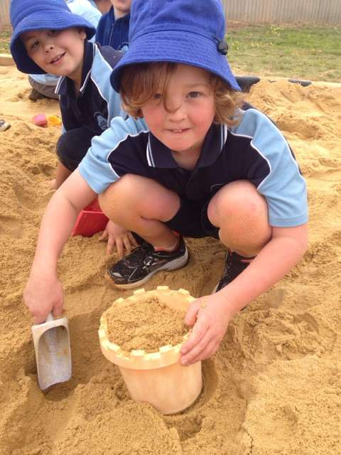
Play is the natural way children learn. Even when it looks like children are just playing, their brains are hard at work putting together vital knowledge about the world.
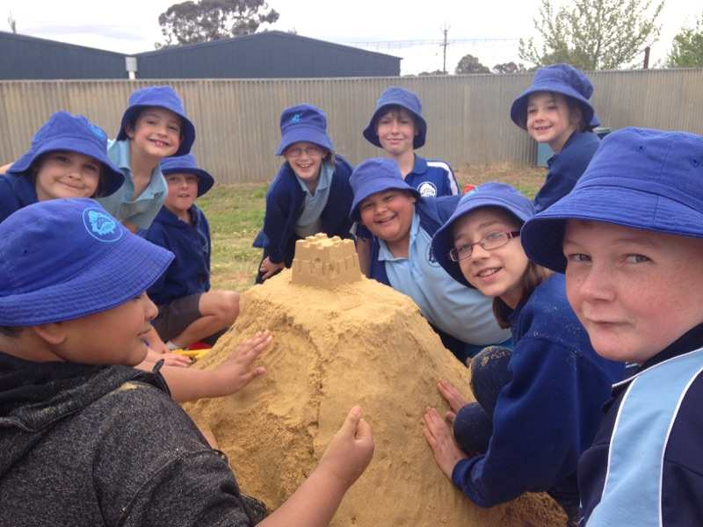

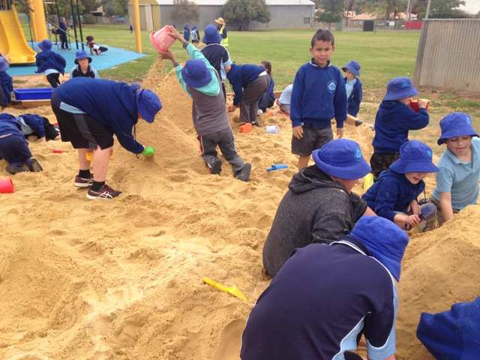

A

Contact Details
Buronga Public School Chapman St Buronga 2739
Phone 03 50232260 Fax 0350212316 Mobile 0457540347
buronga-p.school @det.nsw.edu.au

Buronga Public School

CALENDAR OF EVENTS
Week 2
Monday 17 October Kindergarten School Tour
18 – 20 October State Athletics
19 – 21 October 3/4/5 Camp (Woodhouse)
Week 3
24 – 28 October Swimming Program
Wednesday 26 October Cyber Safety Session – Parents
Friday 28 October Kinder orientation
Week 4
Friday 4 November Kindergarten Orientation
Week 5
Friday 11 November Kindergarten Orientation
Week 6
Friday 18 November Kindergarten Orientation
Saturday 19 November Food Festival
Week 7
Friday 25 November Kindergarten Orientation
Week 8
Friday 2 December Kindergarten Orientation
Week 9
Friday 9 September Written reports home
Week 10
Tuesday 13 December Presentation Night

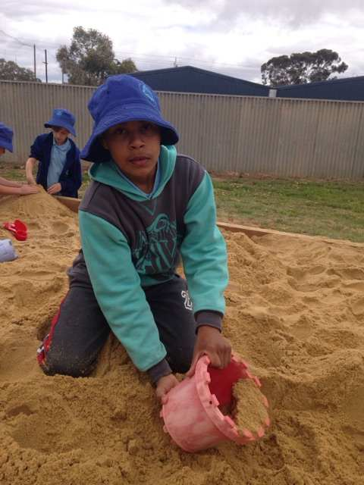

This is our calendar of events so far. As you would be aware term four is extremely busy and dates are filled very quickly. We will keep you updated as important dates are added.
School Website

Our school website is regularly updated with school news and events. Newsletters are uploaded each fortnight and our calendar regularly updated as new events eventuate. You can also access notes that have been sent home on the website. If you go to the calendar, click on the event and you will see notes attached. This may be helpful for those notes that don’t get home for whatever reason.

Happy Students – Successful Students
CLASS NEWS
K/1 New
Welcome back to a very busy Term 4. Next week is swimming, notes need to have already been returned. Please do not send your child to school with bathers under their clothes - it is unhygienic and there will be plenty of time to get changed at the pool. Remember to pack a plastic bag for wet bathers and towels.
The International Food Festival is coming up very soon. Hope you can sell lots of raffle tickets and help out on the evening.
This term the students are learning all about Australia, its history and heritage, geography, culture and unique aspects. I have already learnt things I did not know!!
Until next time, Thanks, Louise

Grade 3/4 News
Welcome to Term 4! It has been a busy couple of weeks. Last Thursday we visited the Mildura Show for the annual Water Week activities. The students really enjoyed the day and learning about caring for our precious water resource. There is a photo spread later in the newsletter. Thank you to Mrs Hunt, Mr Denning, Donna, and Swen for accompanying us to the showgrounds.
Grade 3/4/5 are currently on our excursion to Adelaide. We will have been sending home photos so you can see how much fun we are having.
Don’t forget about our intensive swimming program next week. Please ensure that your child’s belongings are clearly named, as it is easy to misplace items of clothing during the program.
Ms Niemann
Water Week Activities

Last week our grade 3/4/5/6 were again lucky enough to attend the National Water Week on Show at the Mildura Show. The event is a hands-on interactive and fun learning opportunity conducted on the Thursday of the Mildura Show to support National Water Week. Buronga Public School students rotated through two or three activities with an environmental focus.

The students enjoyed activities from a variety of agencies including Mallee Catchment Management Authority, Eaton Gorge Theatre Company, EnviroEduc and Landcare.
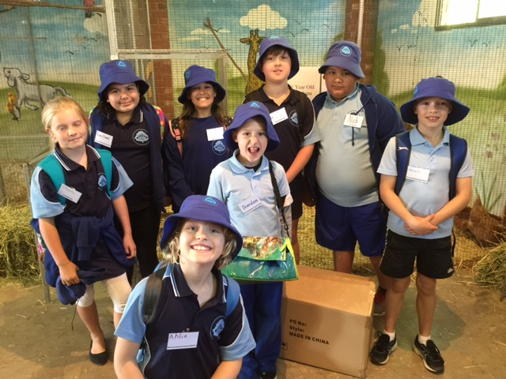

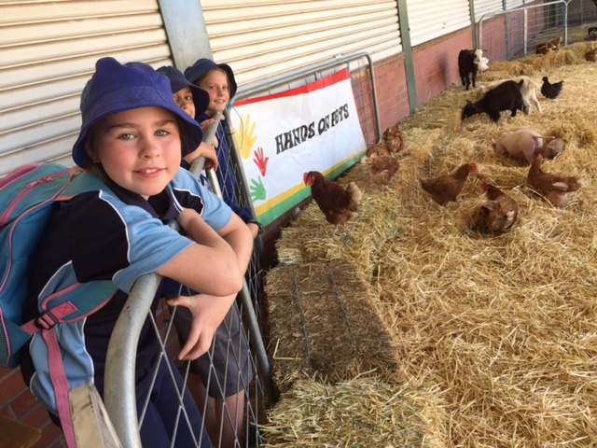
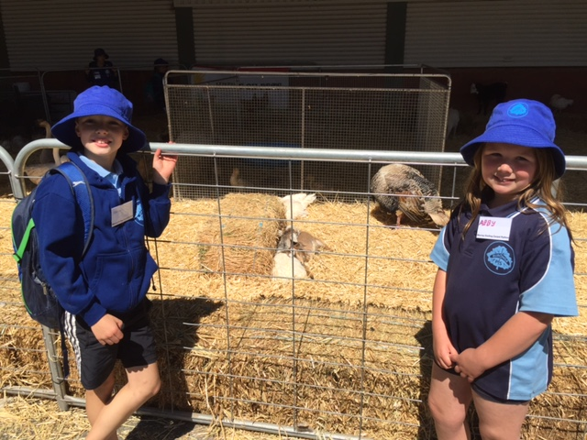

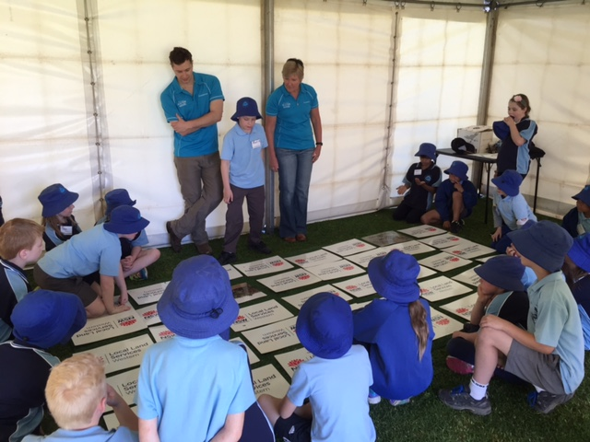

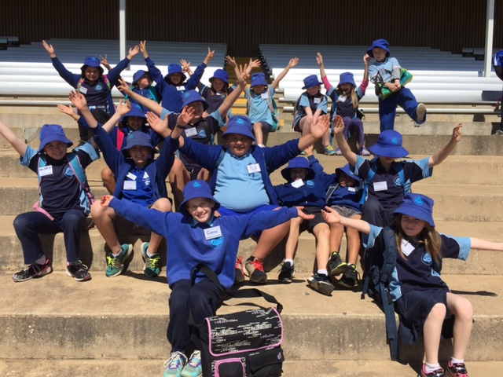

Attendance
Regular attendance at school is essential if students are to maximise their potential, and encouraging regular attendance is a core school responsibility.
Schools, in partnership with parents, are responsible for promoting the regular attendance of students. While parents are legally responsible for the regular attendance of their children, school staff, as part of their duty of care, monitor part or whole day absences.
Please make sure your child/children attend school every day unless they are sick or have approved leave. Every time your child is absent, they miss vital learning opportunities and are disadvantaged in terms of learning time and often progress. We work hard to provide the best possible learning opportunities for your children and need your support in making sure your child is here and on time.

PARENT INFORMATION AFTERNOON

Cyber Safety Information Evening Wednesday 26 October 2016 2.00pm to 3.00pm Buronga PS

Mr Stewart will share some information and ideas about Cyber Safety and strategies that may help with the use of the internet and social media at your place. This will be a great opportunity for parents to find out more about technology and what affect it has on children. The afternoon will provide an opportunity to share ideas and discuss strategies to assist you and your family.
If you would like to attend, please RSVP by calling the school and leaving your name. We will run the Information session with a minimum of ten participants.

Buronga Swimming Program

The Buronga Public School Swimming Program will begin on Monday 24 October and continue each day until Friday 28 October. This means your child will receive five swimming lessons with qualified staff from Mildura Waves. Students will be instructed in groups of no more than ten students, meaning their lessons will be appropriate for varying ability levels. All notes and money need to be returned this week. If you do not have your copy of the note it can be accessed on our website or additional copies can be obtained from the front office.
Students will need to bring their swimmers, towel and a plastic bag for wet swimmers each day.
Swimming is part of our Physical Education learning program and all students are expected to participate. Please contact the school and let us know if there is a reason why your child is unable to participate.

Adelaide Camp to Woodhouse

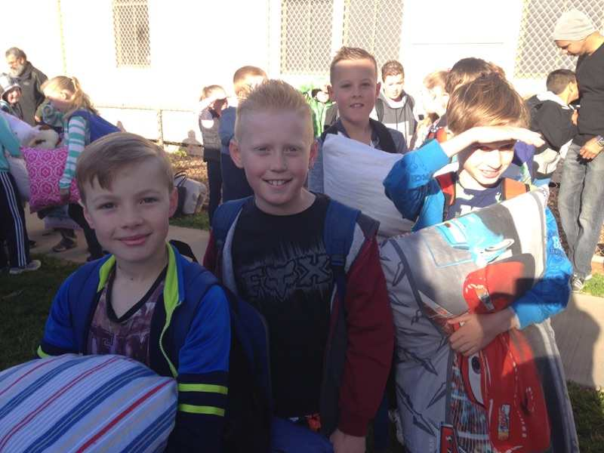
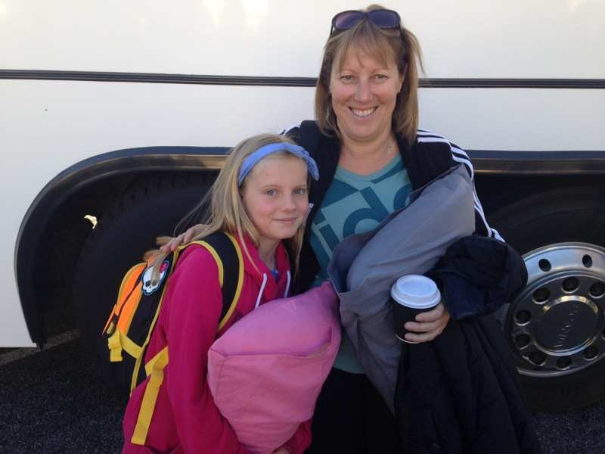
I had the pleasure of seeing our 3/4/5 Buronga Public School and Palinyewah Public School students off to Woodhouse Camp on Wednesday morning. It was wonderful to see so many excited and eager students boarding the bus and enthusiastically waving goodbye.

First Year at School

We have for sale at school the book, “Your Child’s First Year at School.” This publication is put out by Early Childhood Australia, which is a non-profit, non-government early childhood advocacy organisation.
The book outlines information, tips, and strategies about:
- Getting ready for school
- Starting school
- Learning and Development
- Curriculum in the first years
- Emotional wellbeing and social skills
- Learning literacy
- Learning numeracy
- You and your child
- Working with your child’s school
- Keeping in touch
- Contacts and information.
If you wish to purchase a book, they are for sale at the Buronga School office at a cost of $20.00. Goods must be paid for before being collected.

All members of the public are welcome
Encourages fitness, fun and achieving personal bests.

Registration/try outs

31st October, Dareton. 3rd November, Wentworth

Training: 5:15pm every session

Monday: Dareton Pool

Thursday: Wentworth & Dareton Pools

2016/17 Fees:
$175 competitive swimmer
$150 non-competitive
$104 junior dolphin program

Fees do not include season tickets to Dareton Public Pool (phone Wentworth Shire for enquiries)
Fees entitle the members to training (5 months), insurance, Sunraysia Swimming Fees and entry to some competitions.

For more information contact
Teresa Crisp (Coach)
ph: 5027 4701 email: teresa@plummer.com.au
or Amber Baird (President)
ph: 0428 272 271 email: amberbairdsp@gmail.com

