Buronga Public School students and staff have enjoyed a week of swimming instruction at Mildura Waves. Students received quality instruction from qualified swimming teachers where they participated in water confidence activities, safety instruction including a practical element, stroke technique and fitness.
3/11/ 2016Term 4 Week 4
Buronga Public School
KNOWLEDGE IS POWER
Buronga Public School
Leading into summer it is important for children to understand basic water safety precautions and to develop water skills to assist them during all those wonderful summer activities.
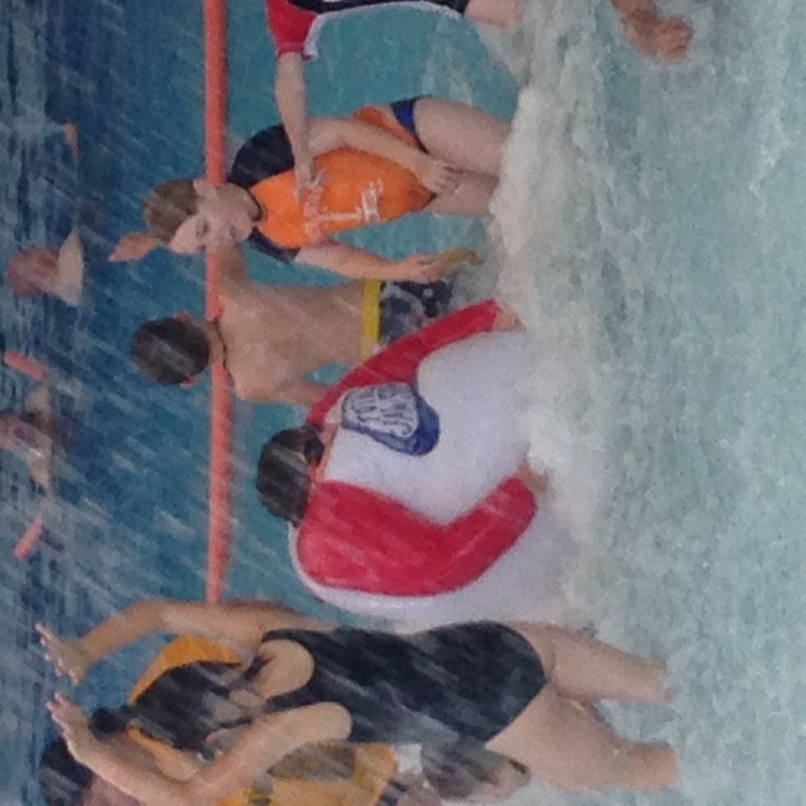
On our last day of lessons, we were lucky enough to have some time in the waves pool along with bubbles and water sprays. This was a great way to conclude our swimming program.

Can you guess who is making good use of the bubbles?
http://www.swimandsurvive.com.au/

Happy Students – Successful Students
Buronga Public School
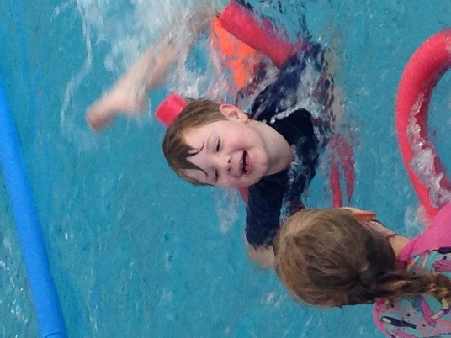
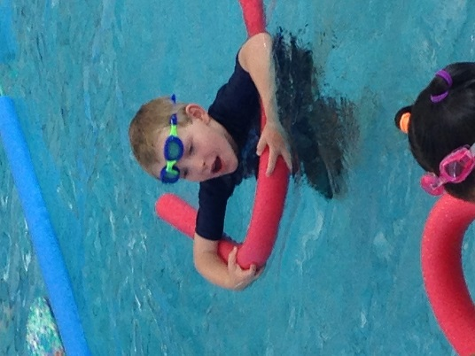
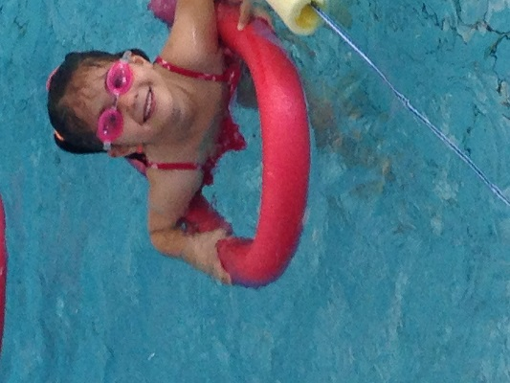
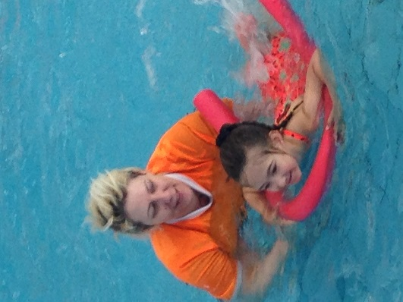

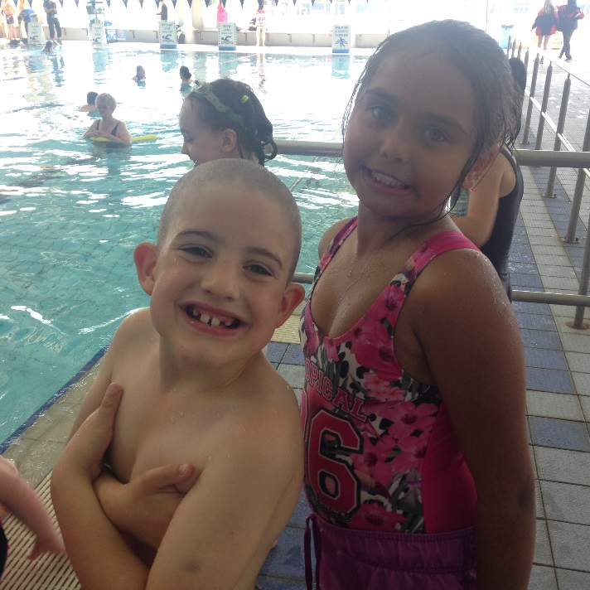
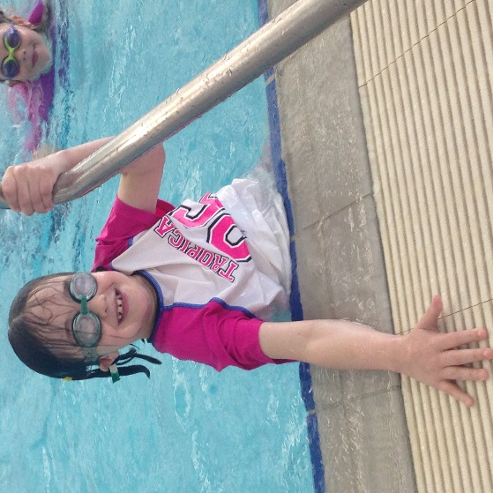

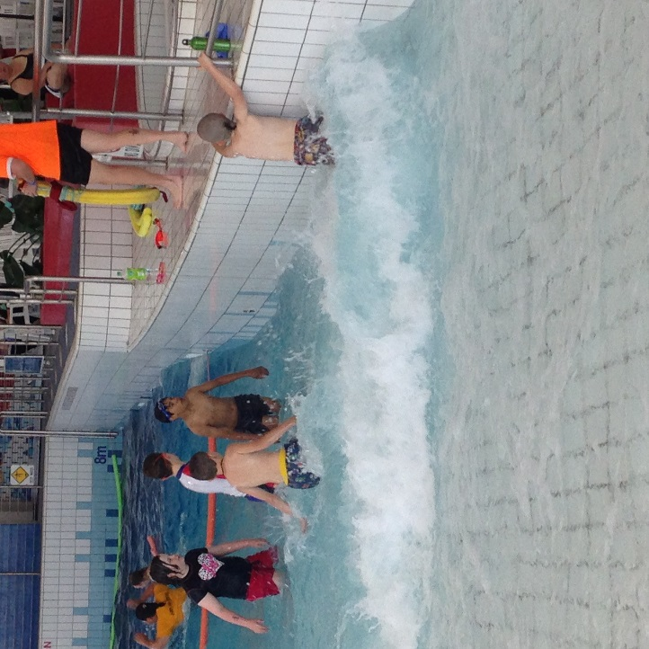
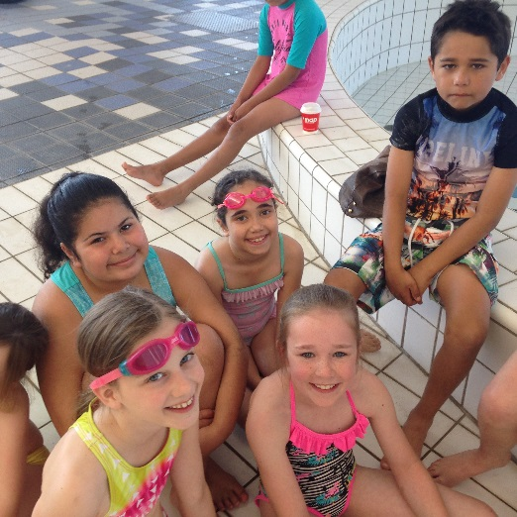

Happy Students – Successful Students

CALENDAR OF EVENTS
Week 4
Wednesday 2 November Links to Learning
Friday 4 November Kindergarten Orientation
Week 5
Wednesday 9 November Links to Learning
Thursday/Fri 9/10 Nov Jodie Principal meeting
Friday 11 November Kindergarten Orientation
P&C lunch
Week 6
Wednesday 16 November Links to Learning
Friday 18 November Kindergarten Orientation
Saturday 19 November Food Festival
Week 7
Monday/Tuesday 21/22 Nov Jodie in Broken Hill
Wednesday 23 November Links to Learning
Friday 25 November Kindergarten Orientation
P&C lunch
Week 8
Wednesday 30 November Links to Learning
Friday 2 December Kindergarten Orientation
P&C lunch
School Disco
Week 9
Wednesday 7 November Links to Learning
Week 10
Tuesday 13 December Presentation Night
Friday 16 December Written reports sent home

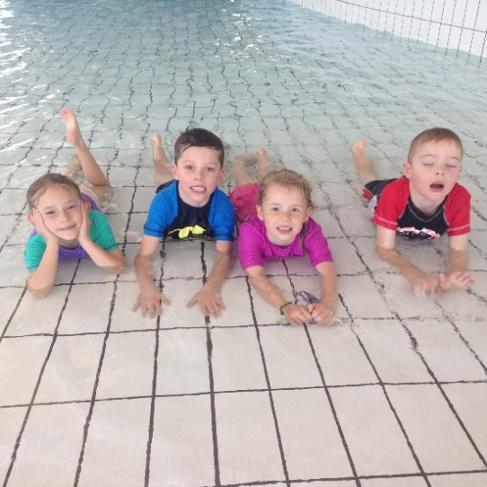

This is our calendar of events so far. As you would be aware term four is extremely busy and dates are filled very quickly. We will keep you updated as important dates are added.
School Website

Our school website is regularly updated with school news and events. Newsletters are uploaded each fortnight and our calendar regularly updated as new events eventuate. You can also access notes that have been sent home on the website. If you go to the calendar, click on the event and you will see notes attached. This may be helpful for those notes that don’t get home for whatever reason.

Happy Students – Successful Students
CLASS NEWS
K/1
We had an excellent time at swimming last week and all students need to be congratulated for their positive attitude, great behaviour and not one single sock went missing!!! While it was tiring, water safety is a valuable skill living in Mildura.
The Melbourne Cup day picnic was very successful. K/1 are good cooks and make the best club sandwiches. Thanks to Mrs Cock for all the preparation needed.
As the year is nearly over, if you have any questions about your child's progress, please come in to make an appointment time to discuss any matters arising. However, classes and teacher for next year have not yet been organised.
Keep those reader folders returning, most students are well on track to achieve or exceed their reading goal by the end of the year.
Thanks, Louise

1/2
Can you believe it is already week 4? Last week the children had a wonderful week with our intensive swimming program. We have been writing about the things we participated in and revising the water safety component.
This term the students are learning all about Australia, its geography, culture, history and heritage. As a part of this unit the children celebrated Melbourne cup day. They helped prepare a picnic lunch and had a lovely time sharing this with the K/1 class.
Not long now to the Buronga Food Festival. Thanks to families that have offered to help and have been selling raffle tickets. It is a fantastic event and I am looking forward to seeing you all there!
With the weather warming up it’s a good idea to just make sure your child has a drink bottle and hat every day.
Keep up the fantastic home reading!
Have a great week. Mrs Bernadette Hogarth

Grade 3/4 News
Wow week four already!!! Grade 3/4/5 had a wonderful time on our Adelaide excursion! All students showed excellent behaviour and the camp leaders commented on what a lovely group of students they were. Well done everyone!
A huge well done to all students in Grade 3/4 for swimming last week! Especially after a busy time on our excursion, students tried their best and all students showed pleasing improvement over the course of the program.
We are working hard on our multiplication and division at the moment. PLEASE ensure students are practicing their tables and reading at home because this practice helps to reinforce the skills we are working on at school.
Ms Niemann

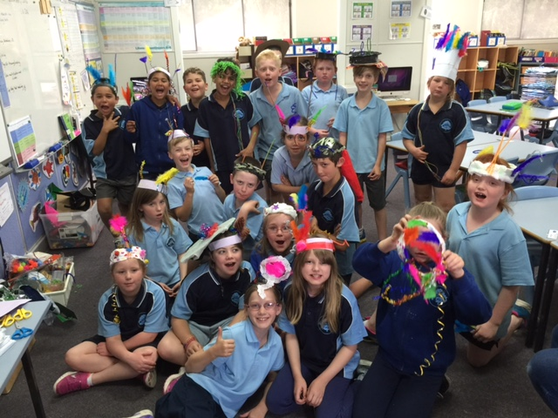

News from Casa del 4/5/6
What a busy term it is. I don’t think I’ve publicly congratulated the year 6 children for their behaviour in Canberra. Well done year 6. If any year 6 parents haven’t got the photos I took on camp let me know. I have shared the folder with year 6 through Google Drive but I am able to put them on a USB stick if you bring one in for me.
The rest of this term is going to be very busy with presentation night practice, year 5 captain speeches, report writing and of course the International Festival. Year 6 students were given packs form Coomealla HS this week. These packs include information about orientation day, parent information nights and other important documents. Please make sure you read all of the information so you don’t miss out on any events.
Greg
P&C News

Hello Parents & Families!

We are very busy getting all the last minute details sorted for Festival on November 19th. The time has changed this year with Festival running from 5PM to 8PM. Cake trays will be sent home this week for our Cake Stall. We also still need your lucky jar donations.

We still need some volunteers to help. If you can volunteer your time, it would be greatly appreciated! The P&C cannot make the Food Festival successful without the support of the parents, families and community members who volunteer their time.

Keep selling those raffle tickets! Sold books and money can be dropped into the P&C box in the office. There are also extra books on the P&C box if you would like to sell more.

We will also be having a second hand stall. If you have any quality items to contribute they would be greatly appreciated. Items can be left at the school.

There is a P&C meeting tonight at 6.30pm at the school.

I am usually at the school at pick up, so if you have any questions, feel free to ask!

Thanks!
Sarah

Buronga Music Program

Music is an activity that activates, stimulates and uses the entire brain. Buronga Public School students enjoy the benefits of weekly music lessons with a specialist music teacher and are making some fantastic progress.
Engagement in music programs:
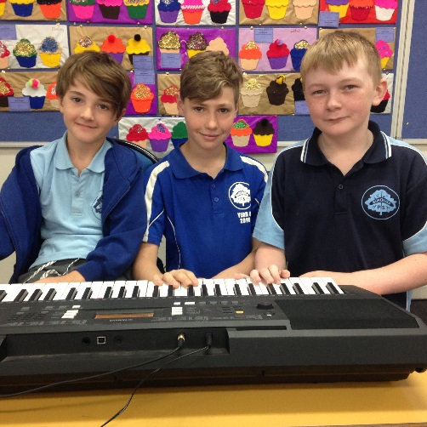
- Enhances fine motor skills
- Prepares the brain for achievement
- Fosters superior working memory
- Cultivates thinking skills
- Improves recall and retention of verbal information
- Boosts reading and English language skills
- Boosts creativity
- Allows disengaged students to re-engage with learning
- Builds trust
- Builds confidence
- Builds resilience
I would like to extend a huge thank you to the P&C for supporting our Music program by funding new music resources.

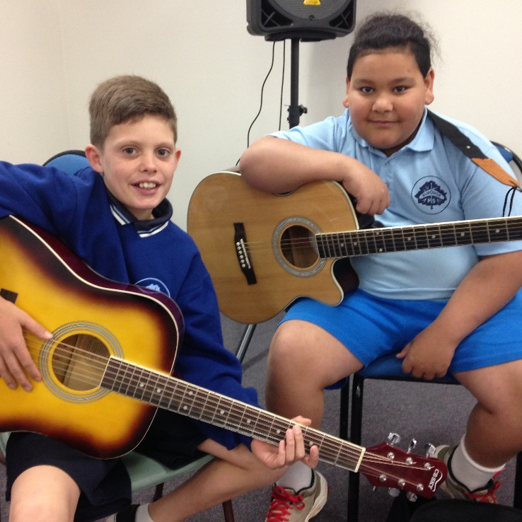
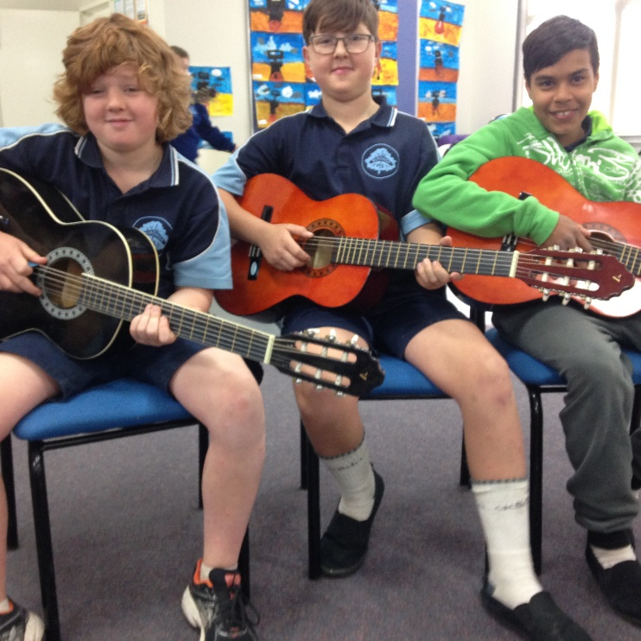

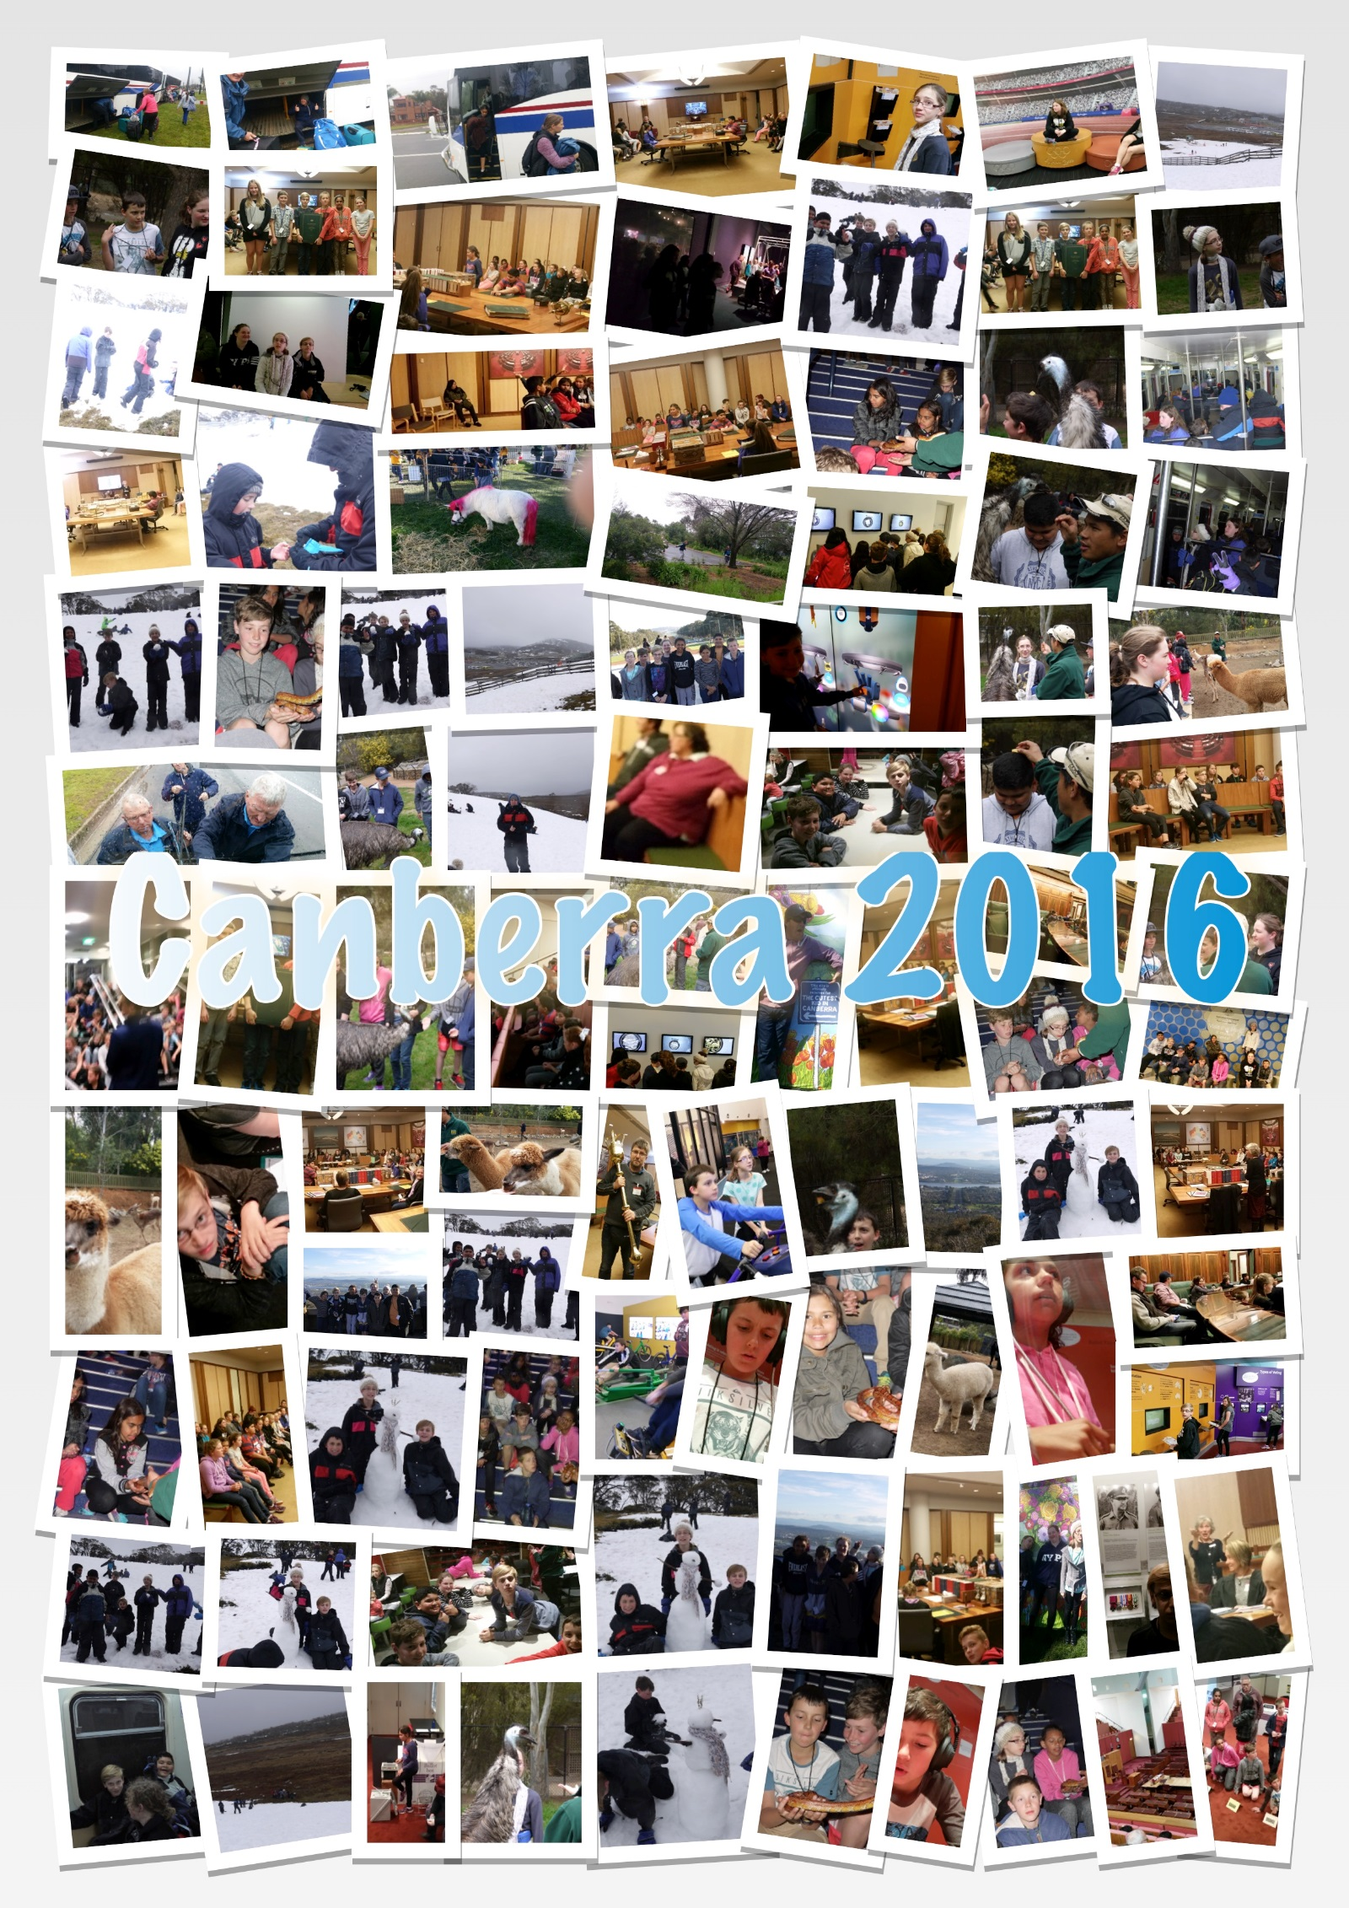

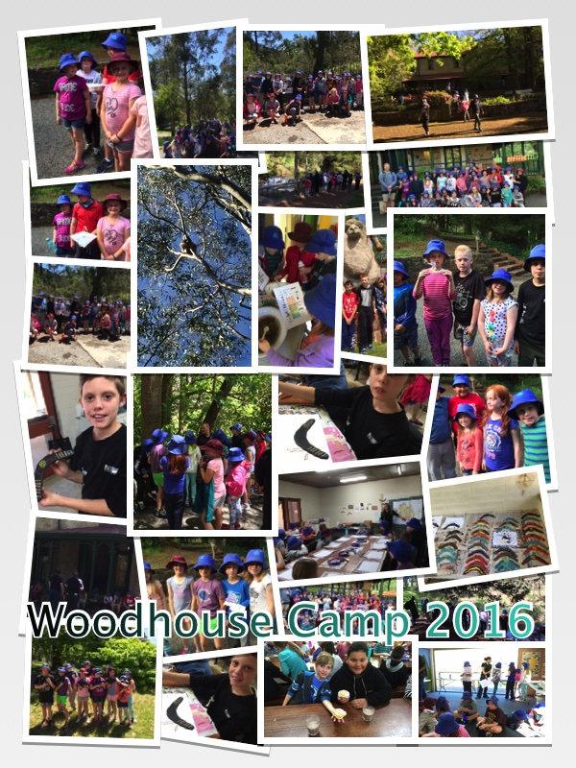

K/1/2 Picnic Lunch
As part of our Health and Nutrition Program, students from K/1/2 enjoyed preparing a beautiful picnic lunch for Melbourne Cup Day celebrations. After preparing the food, students and teachers enjoyed the beautiful weather while sharing the feast.
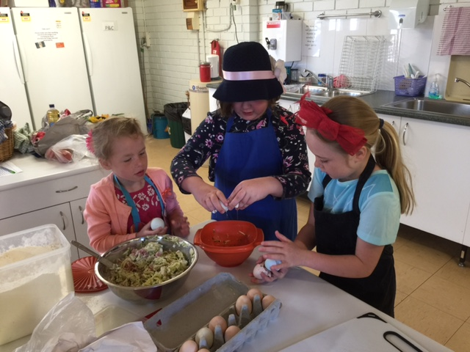
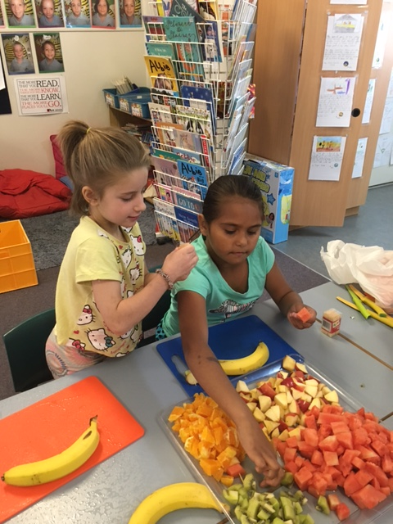

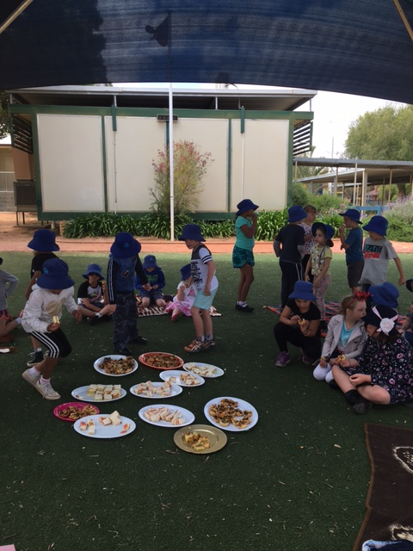
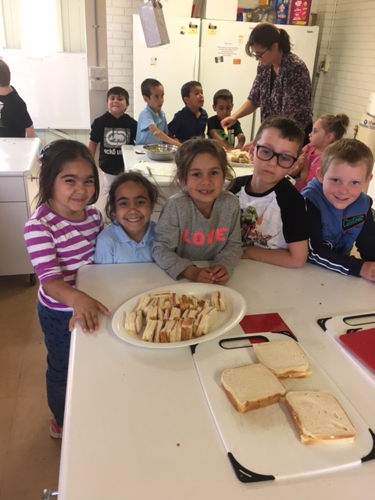
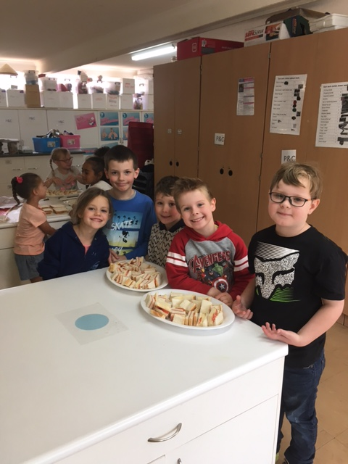

Recipes from our Health and Nutrition Program

Fried Rice
1 cup of Long Grain Rice, cooked and cooled
2 eggs, lightly beaten
½ cup frozen peas and corn, rinsed and drained
1 onion, cut into thin wedges
200g diced bacon
1 carrot diced into small pieces
2 tablespoons of oil
2 tablespoons of Soy Sauce.
100g of beans
1. Heat 1 tblsp of oil in frypan or wok and pour in the eggs.
Cook the eggs as a flat omelette, turn and cook the other side.
2. Remove the omelette from the pan, cool slightly and chop into strips.
3. Heat the remaining oil in the pan, add the onion and stir fry until it becomes transparent, add the bacon and carrot and stir fry 1 minute more.
4. Add the rice, peas and corn and stir-fry for about 4 minutes, or until heated through and slightly golden.
5. Stir in the omelette, bean shoots and soy sauce and cook for 1 minute.
Zucchini Slice
1 cup Self Raising Flour
1 cup grated cheddar cheese
5 eggs
375g Zucchini
1 large onion
3 rashers of bacon
½ cup of oil
salt and pepper
1. Pre-heat oven to 180C
2. Coarsely grate unpeeled zucchini and finely chop onion and bacon.
3. Combine zucchini, onion, bacon, cheese, flour, oil and lightly beaten eggs, season with salt and pepper.
4. Pour into a well-greased tin (16cm x26cm)
5. Bake for 30-40 minutes or until golden br
Attendance
Regular attendance at school is essential if students are to maximise their potential, and encouraging regular attendance is a core school responsibility.
Schools, in partnership with parents, are responsible for promoting the regular attendance of students. While parents are legally responsible for the regular attendance of their children, school staff, as part of their duty of care, monitor part or whole day absences.
Please make sure your child/children attend school every day unless they are sick or have approved leave. Every time your child is absent, they miss vital learning opportunities and are disadvantaged in terms of learning time and often progress. We work hard to provide the best possible learning opportunities for your children and need your support in making sure your child is here and on time.

Visitors in the school
The staff of Buronga Public School is committed to providing a safe learning environment that enhances the fairness, tolerance, integrity, and knowledge. The contribution of visiting members of the school community is an integral part of our school and is highly valued. The Parents, Carers and Visitors Code of Conduct has been developed in accordance with the N.S.W. Department of Education guidelines and ensures that everyone who visits the school site is able to do so in a safe and harmonious manner and ensures that students, staff, parents, carers and other visitors are able to work together to ensure an uninterrupted and respectful environment for learning.

Code of Conduct for Parents/Carers and Visitors

All parents/carers and visitors are expected to:

- treat all persons associated with the school with respect and courtesy
- ensure their child/children are punctual to class every day
- vacate the school grounds once classes commence
- sign the visitors book in the front office if staying during school time to assist in classrooms etc.
- direct their child to the play area monitored by duty teacher
- monitor all pre-school children who must stay with the accompanying adult at all times (this includes any school special event such as Open Days, assemblies & P&C events))
- make mutually convenient appointments to obtain an interview with school staff. Teachers are not available during teaching time or while on playground duty due to duty of care requirements
- allow staff to supervise, investigate and manage students without interference
- discuss issues or concerns about the school, staff, other parents or students through the correct school procedures

Kindergarten Orientation Program

Our Kindergarten Orientation Program has started and we welcome our new students and families for 2017.
The student and parent sessions begin at 2.00pm. We are unable to accommodate our new students prior to this time on the day due to other commitments with current Buronga students.
Part of our program also includes our Year 5 visiting the Gol Gol Preschool so some of our new students have the chance to meet their school buddy. School buddies assist younger students with various day to day activities and act in a supportive role.
During our transition sessions students will spend time in the Kindergarten classroom with their teacher for 2017. During this time student will have the opportunity to participate in:
- Learning school routines
- Craft
- Outdoor play
- Listening to stories
- Creative and developmental play
Parents will have the opportunity to spend time in information sessions with the Principal and various school and support staff while your child attends class sessions. Information sessions will include:
- School routines/expectations/policy
- The Curriculum
- Learning and Support (staff and services)
- Wellbeing & Health
- Parent and Citizen Association
- Community Engagement

Dates for our Transition Program are as follows.
Friday 28 October 2.00-3.00pm
Friday 4 November 2.00 – 3.00pm
Friday 11 November 2.00 – 3.00pm
Friday 18 November 2.00 – 3.00pm
Friday 25 November 2.00 – 3.00pm
Friday 2 December 2.00 – 3.00pm

Contact Details
Buronga Public School Chapman St Buronga 2739
Phone 03 50232260 Fax 0350212316
Mobile 0457540347
buronga-p.school @det.nsw.edu.au

