I would like to extend my appreciation and admiration to all students, families, friends, staff and community members who helped to make our Buronga Food Festival 2016 such a wonderful success. This event not only raises funds to extend and improve opportunities for students at Buronga, but is a fantastic opportunity for community engagement where we all work together to provide the best possible educational experiences for students. I am a firm believer that a strong and authentic link between home and school improves educational outcomes for students. It only makes sense that we work together to achieve a common goal, which is quality education for all students.
1/12/ 2016Term 4 Week 8
Buronga Public School
KNOWLEDGE IS POWER
Buronga Public School
Our food stalls included cuisine from a variety of origins, including: Italian, Greek, Indian, Canadian, The Aussie BBQ, Tongan, Asian, English, Mexican, American, and Aboriginal. We also indulged with some fabulous desserts.
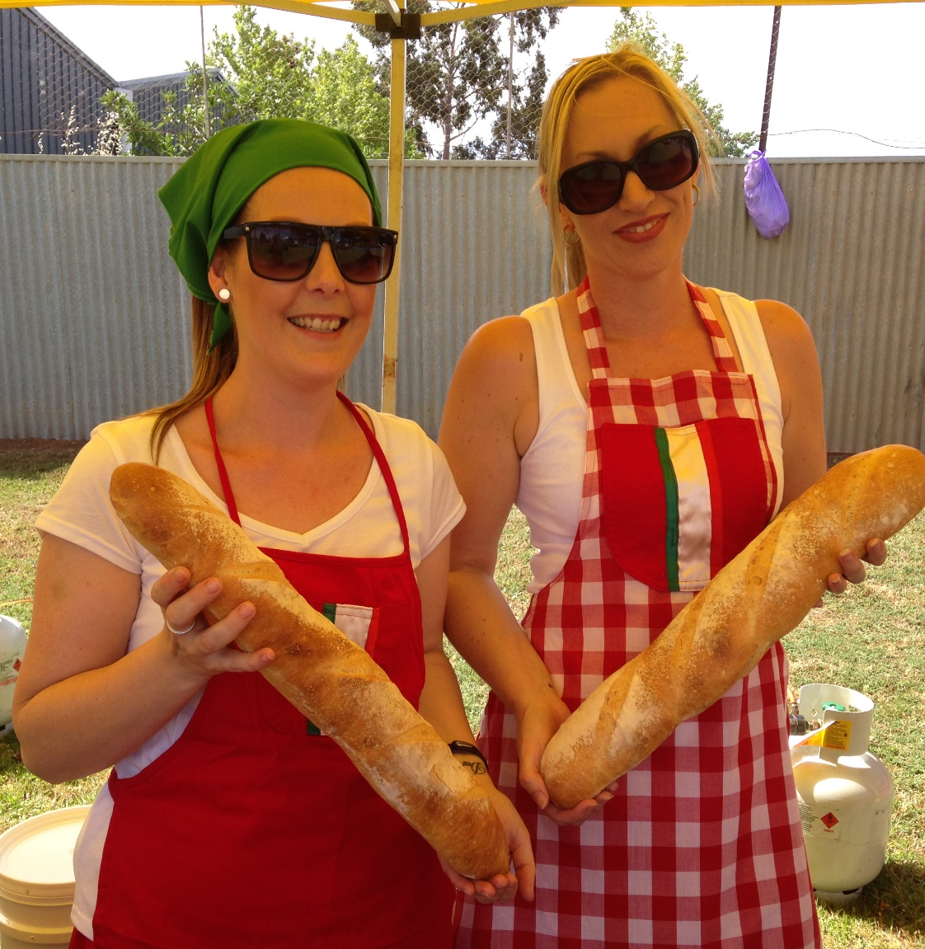

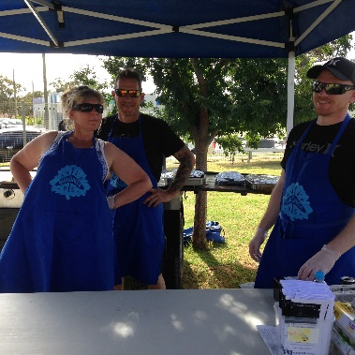
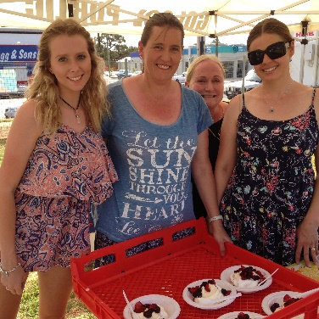

Buronga Public School Food Festival 2016
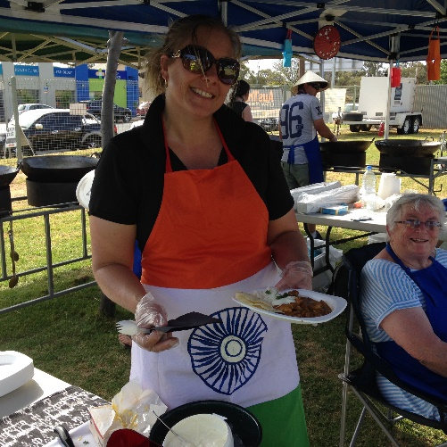
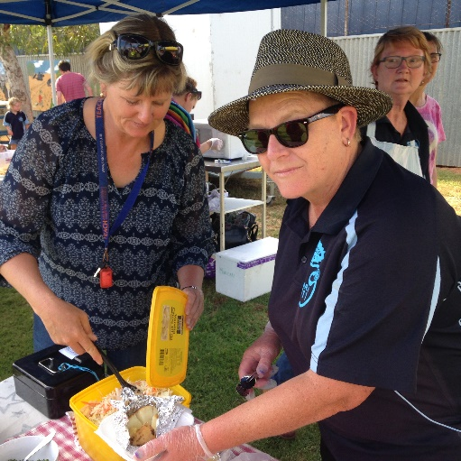
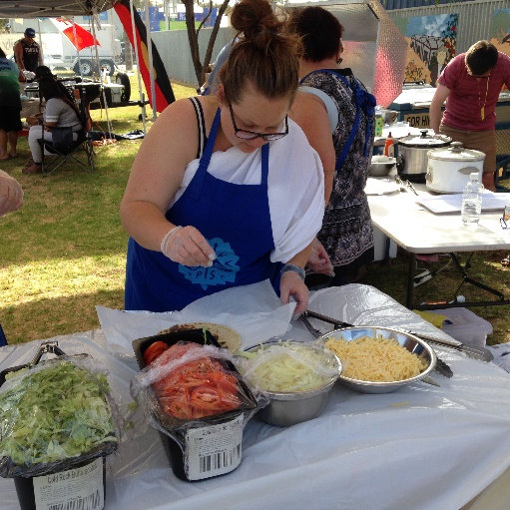

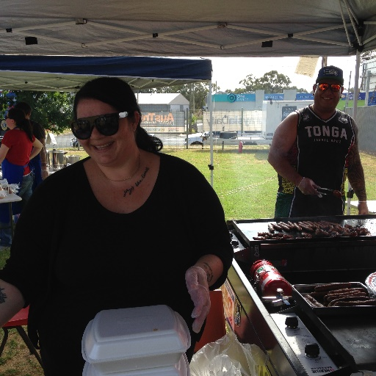
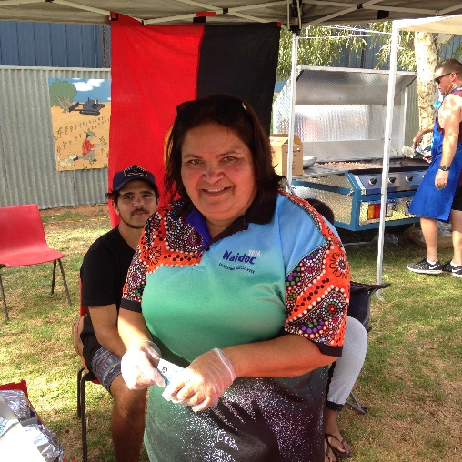
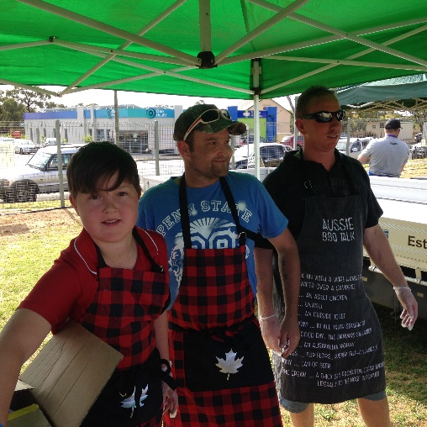

What a wonderful way to celebrate our rich heritage and diversity.
Thank you to all involved, your contribution makes all the difference.
Special thanks to the Buronga Public School P&C.
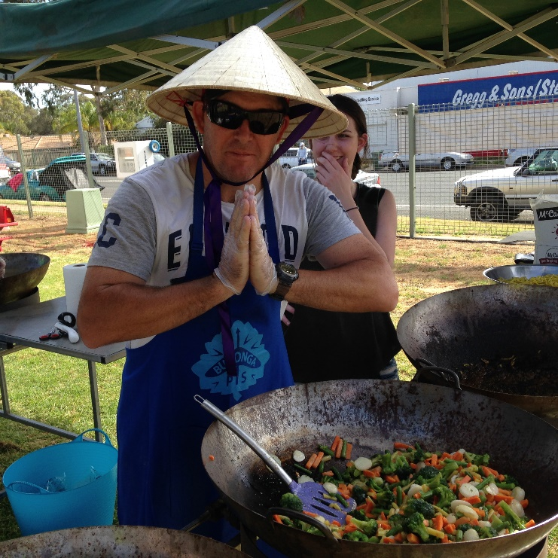
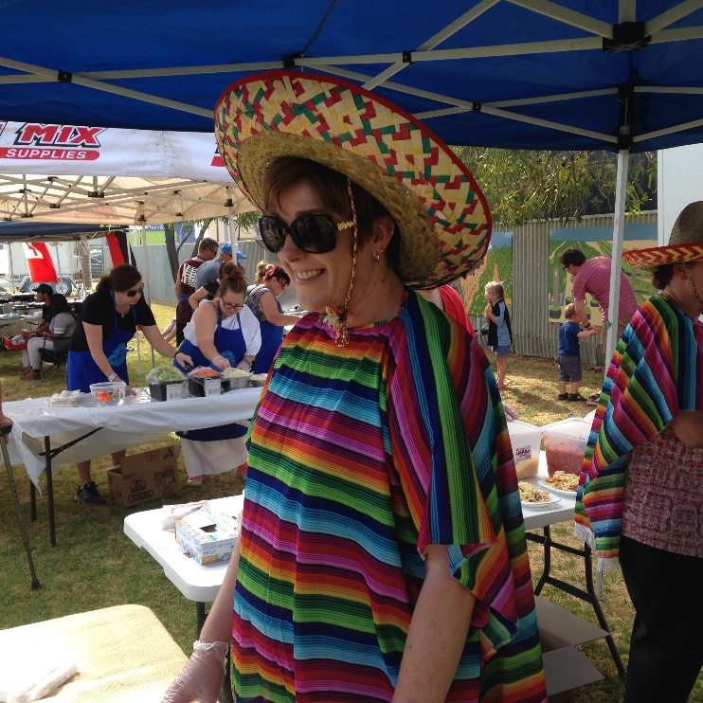

CALENDAR OF EVENTS
Week 8
Wednesday 30 November Links to Learning
Friday 2 December Kindergarten Orientation
P&C lunch
Week 9
Wednesday 7 November Links to Learning
Thursday 8 December Year 6 Dinner
Friday 9 December P&C School Disco
Week 10
Tuesday 13 December Presentation Night
Tuesday 13 December Written reports sent home

2017
Teachers return to school for Staff Development Days 1st/2nd/3rd February.
Year 1 to 6 students return to school Monday 6th February
Kindergarten students return to school on 8th February
Kindergarten Best Start testing begins on 6^{th/7th} February. You will receive a time and date for your child’s Best Start testing time at Kindergarten Orientation program.

Contact Details
Buronga Public School Chapman St Buronga 2739
Phone 03 50232260 Fax 0350212316
Mobile 0457540347
buronga-p.school @det.nsw.edu.au

Happy Students – Successful Students
School Website
Our school website is regularly updated with school news and events. Newsletters are uploaded each fortnight and our calendar regularly updated as new events eventuate. You can also access notes that have been sent home on the website. If you go to the calendar, click on the event and you will see notes attached. This may be helpful for those notes that don’t get home for whatever reason.
Students perform to a full house and a special visitor.
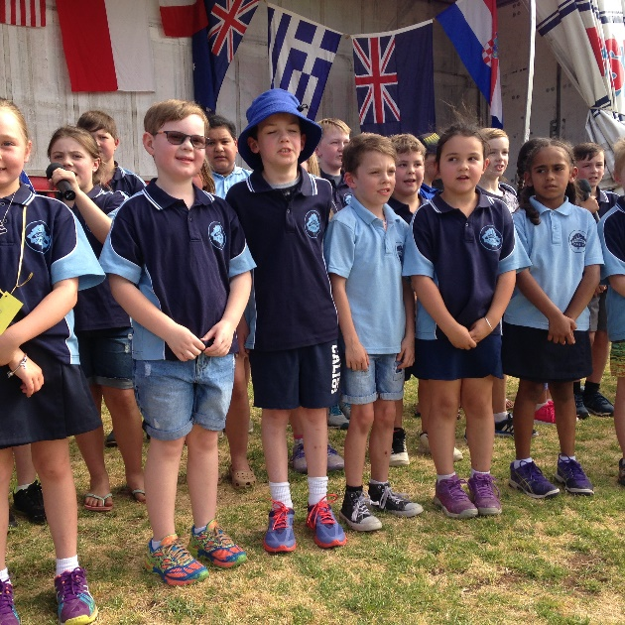
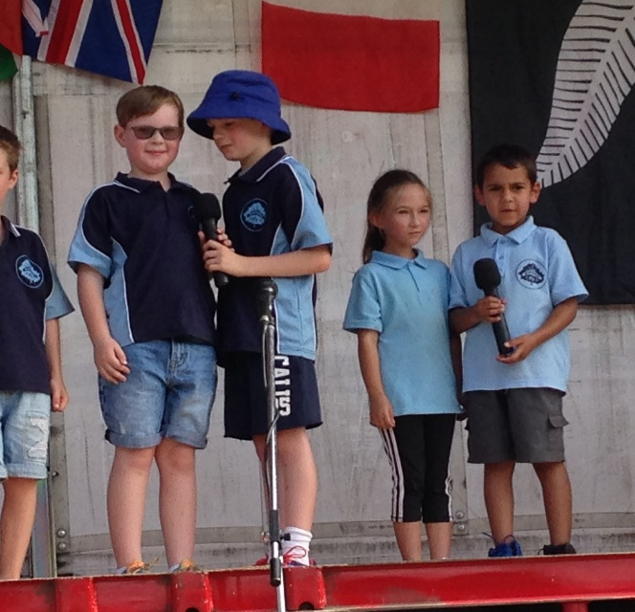

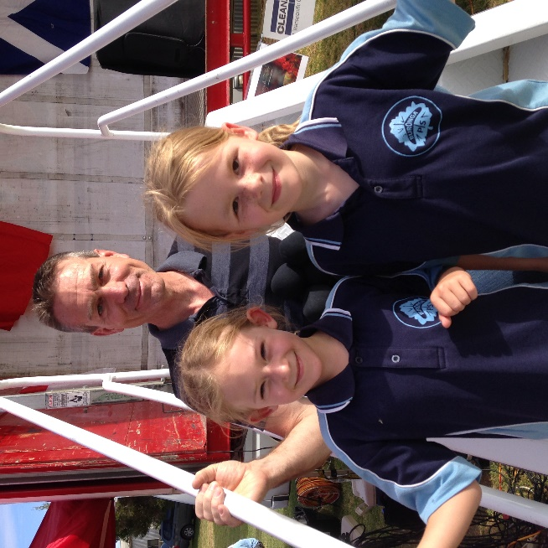

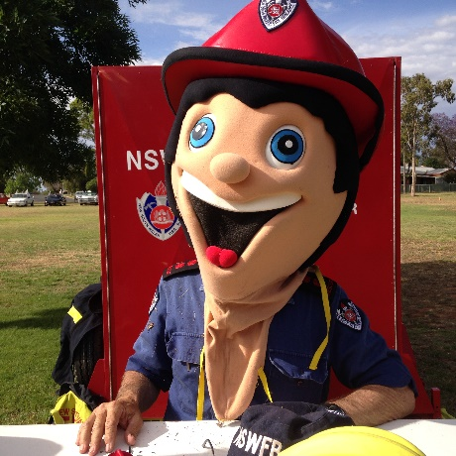
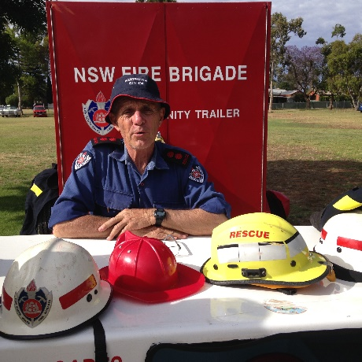

Engaged in Learning
Stick insects in grade 3/4
At the start of the year Mrs Niemann brought in some baby stick insects for the class to look after for the year. When she brought them in, they were only babies. There are three. Since they first arrived they’ve moulted and grown ten times their size! We thought of some names for the stick insects.
Every week we change the leaves that they eat. They eat gum leaves. Every day we spray them with water to give them a drink and hydrate them. They are leafy stick insects.
We have one boy and two girls. When they mature, they will lay eggs that take between six months and two years to hatch. When grown up stick insects lay their eggs, ants find them and take them to their ant nest. There is a little lump on the end of the egg that the ants like to eat so the ants eat the lump and leave the egg there. When the egg hatches the stick insect looks like an ant so the ants look after it until the stick insect is grown up a bit more. When the insect leaves the ant nest it acts like a scorpion. When the insect is fully grown, it climbs up a gum tree and acts like a stick insect.
By Codie McDermaid

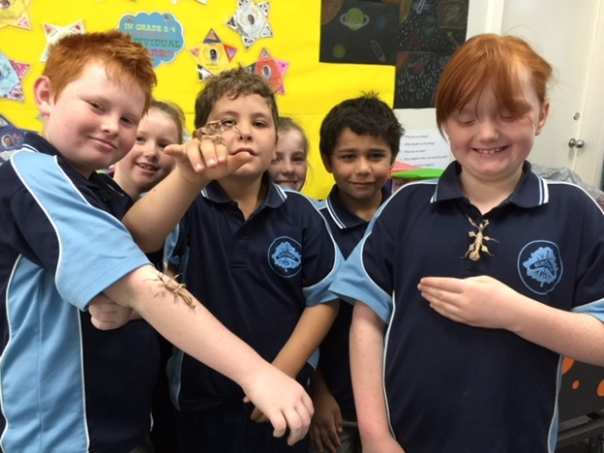
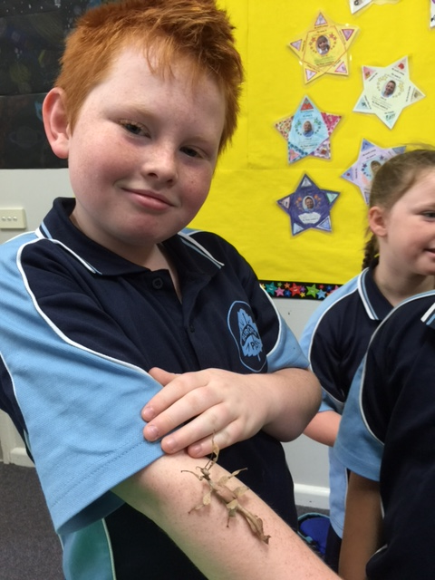

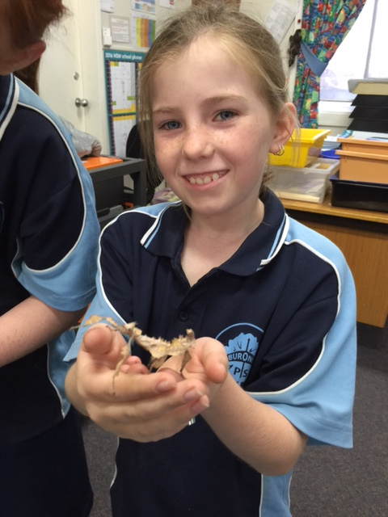

CLASS NEWS
K/1
Over the past two weeks the class have produced some beautiful pieces of art of native Australian plants and flowers. Please take the time to come into the classroom and have a look. They look stunning.
At the moment I am busy writing reports and completing some mandatory assessments. If you have any concerns or questions about your child's progress over the year please make an appointment to see me. Or, alternatively pop in to say hello at the end of the day. Children feel more valued if an interest is taken in what they have done at school.
Reader folders will not be going home after next week. If you still wish to read, go to the local library and read some quality fiction to your child. There are so many lovely picture books around. Most libraries will be running a summer reading program which is free and usually starts the first week of December.
Thanks, Louise

1/2 Newsletter
Firstly I would like to personally thank everyone for their kind words, cards and flowers on the passing of my mother. It certainly has made it a little easier for me knowing people care. I have had a very busy but lovely week back. I have been busy with testing and gathering data. The children have shown great improvement in lots of different areas. We will be sending work home in the next week or two. Could the children please bring in some extra plastic bags for work? If your child has any library books could they return them as soon as possible? We are very busy practicing for the school performance. The children are doing an amazing job and we are looking forward to performing on the night,
Just a reminder as the warm weather is upon us that all children need to have a hat otherwise they must stay in the shade.
Thanks to all the volunteers that helped out at the Buronga International Food Festival. It was a great night! The children have written some wonderful recounts about the event.
Have a lovely week.
Bernadette Hogarth
Grade 3/4 News
The term is going so quickly! We have been working hard on our tables this term. It is great see the students improve their times and accuracy. Please encourage the students to practice their tables at home to assist their improvement.
We have also been working hard on our dance presentation. I have sent home a note about what we are wearing for our item on Presentation night. Please come and see me if you have any queries.
Please ensure that students are bringing their hats every day. UV indexes are very high at the moment and we need to ensure hats are being worn when in the playground.
Can readers and library books please start being returned to school next week? Have a hunt for any missing ones so we have all our books back for the new school year.
Ms Niemann

News from Casa del 4/5/6
Dear Parents
There are a few big events happening over the next couple of weeks. The year 6 farewell dinner is on December 8 at 6:30pm and is at Fasta Pasta. A note has gone home about it. Please see either myself, Mrs Hunt or Mrs Treverrow if you have questions. On Friday 9th at 9:00 am Year 5 children will have the opportunity to give their School Captain speeches at our last assembly of the year. Voting will take place straight after the assembly. The final big event of the year is Presentation night. Our class has been working hard with Mr Robinson and Mrs Hunt on their performances for the night.
Have a great Christmas break
Greg
Buronga Public School Cooking Program

We have had some great cooking sessions in the past couple of weeks - I missed the newsletter deadline, sorry. So please find our Tasty taco recipe from the 3/4 session and the delicious lasagna 1/2 made last week. This week K/1 observed what happens when you put yeast powder in tepid water and feed it with sugar. Then we watched what happens when we added the mix to plain flour. And then we made yummy pizzas!
Tasty tacos recipe
Preheat oven to 180°C. Heat a large non-stick fry-pan over high heat. Add mince and cook until browned. Break up large pieces with a spoon.
Ingredients:
- 500g beef mince
- ½ teaspoon cumin
- ½ teaspoon mild paprika
- ½ teaspoon dried oregano leaves
- Salt and freshly ground black pepper
- ½ cup passata
- 1 cups shredded lettuce
- 1 tomatoes, chopped
- ½ carrot, grated
- ½ cup tasty or cheddar cheese, grated

- Hard and/or soft tacos shells
- Salsa, to serve
Method:
Preheat oven to 180°C. Heat a large non-stick frypan over high heat. Add mince and cook until browned. Break up large pieces with a spoon. Add cumin, paprika, oregano leaves and salt and pepper. Mix well to combine, then add passata.
Reduce heat to low and simmer for 10 minutes. Add some water if the mixture becomes too thick. Taste and add more salt if necessary.
Heat taco shells in the oven for 5 minutes (wrap soft shells in aluminium foil).
Place warm shells on a serving platter; offer all the toppings in small bowls.
Lasagne
2 tblsps Olive oil
1 onion, chopped
2 cloves garlic, chopped
500g mince beef
1 375g can chopped tomatoes
½ cup mixed fresh herbs (parsley, oregano, sage, basil etc)
½ bottle pasta dura sauce
Heat the oil in pan and cook onion until slightly golden, stirring occasionally. Add the garlic and cook one more minute
Add the mince to the pan and break it up as it cooks, when it is well browned, add the tomatoes and herbs.
Bring to the boil, reduce the heat to very low and leave to simmer for at least half an hour. Stirring occasionally. (An hour and a half is best if possible.)
While the meat is cooking make a basic white sauce using approx ½ litre of milk, PF S&P and butter.
Melt the butter, stir in the flour, when the roux is cooked add the milk small amounts at a time slowly; stirring constantly allowing mix to come to boil before adding the next small amount of milk.

When meat is cooked cool slightly and then layer lasagne sheets and meat mix alternately.
Top with white sauce, then cover with grated cheese.
Cook in a slow to mod oven for 45 mins.
If cooking to use on a later day cook for ½ only, very gently so as not to burn cheese topping.
Mrs C
Library News
Library News
We have had a busy year in the Library this year with lots of regular borrowers. Our new computer system lets us track and record each time a student borrows and can tell us which class has the best borrowing habits. So collectively well done to the combined Year 1 group and the Year 3’s who were the most frequent borrowers this semester.
Unfortunately it is time to stop the borrowing for this year, so after this Friday there will be no borrowing, just returns. As in the past there will be a candy cane for each book returned commencing Monday of Week 9.
The Christmas book collection will be on display from Monday for students to enjoy here in the Library or in the classrooms.
Mrs C
Class Organisation for 2017

I have included a list of classes that have been organised for 2017 and associated staffing. These plans are made with current information and enrolment numbers. If enrolments change between now and February 2017, our classes and organisation may change as well to accommodate school needs. If you know your child will not be attending Buronga Public School in 2017, could you please let us know so we can adjust our numbers if necessary.

Kindergarten Mrs Louise Olofsson
1/2 Mrs Blanche Niemann
2/3 Mrs Carolyn Tiley
3/4 Mr Tom Denning
5/6 Mr Greg Stewart & Mrs Leanne Hunt
Learning & Support Teacher Mrs Merren Cock
K-2 Intervention Teacher Mrs Bernadette Hogarth
Welfare Support Teacher Mrs Bernadette Hogarth (1 day per week)
Instructional Leader Mrs Kerrie Robson (2 days per week)

It is with great pleasure that we welcome three new staff members to Buronga Public School in 2017. Mr Tom Denning, Mrs Carolyn Tiley and Mrs Kerrie Robson. Their skills, expertise and contributions to Buronga Public School will enhance and build on our current team and we look forward to working together.

Our 2017 staffing includes initiatives to support student learning and to maximise resources within the school. Our focus is to support students through their learning journey and to address individual needs as they arise with the end goal to improve student outcomes and provide quality education.

I will have the opportunity to discuss our new staffing and associated teaching roles at our Information night early in term one. I am genuinely looking forward to a great year with some exciting teaching and learning directions and new programs for students.

If your child is in Year two or Year three, where the grade is split between two classes, I will be contacting families to discuss the decision making process and what will work best for students.

If you have any immediate questions or concerns, please don’t hesitate to call and arrange a time to meet.

Jodie Treverrow
Principal
Buronga Public School

Food Festival Platinum Sponsors

Food Festival Gold Sponsors

