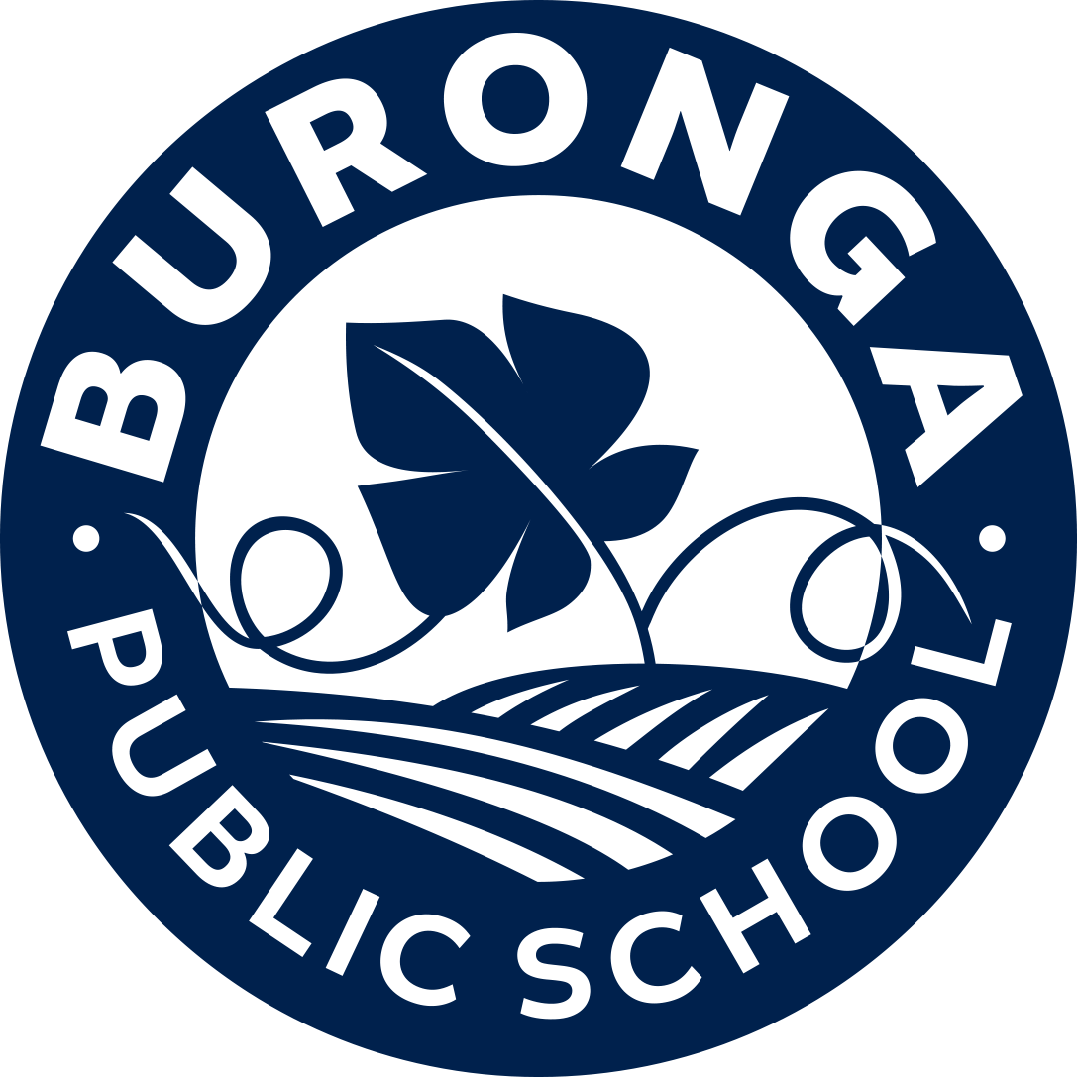
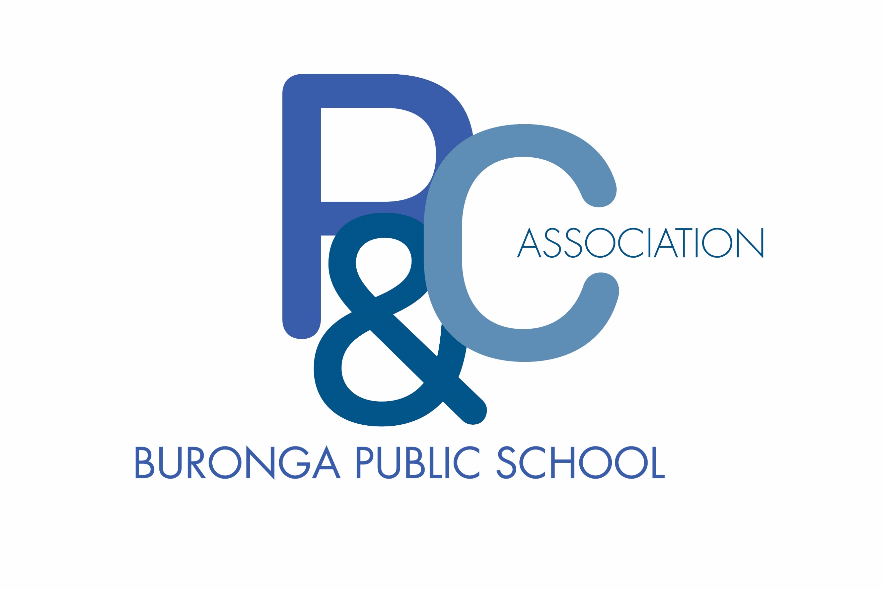
Membership application form
This form is to be completed by any person wishing to become a new member of the Buronga Public School P&C Association. The information collected on this form is only used internally by the P&C Association to contact members in regard to P&C Association meetings and events. The information will not be shared with other organisations in any way.

First Name
Surname
Title
Contact Phone | Home:
 | Mobile:
Contact email
I am applying as a  (please circle) | Parent Member  (You are a parent, guardian or carer of a student enrolled at the school)
Citizen Member
(You do not have a child at the school but your primary residence is within the school enrolment area)
Are you an employee of the NSW Department of Education (please circle) | YES NO
Do you wish your membership information to remain private? | YES NO

I include payment of $1 to become a financial member of the Buronga Public School P&C Association.
I acknowledge that by becoming a member, I agree to abide by the Constitution, by-laws, rules, policies and procedures adopted by the the Buronga Public School P&C Association.
I hereby certify that the information provided on this form is true and correct.

Signature: _______________________________ Date: ______________________

Official Use Only
Proof of residence has been sited | YES NO | Sighted by:
Annual Subscription has been paid | YES NO | Taken by:

