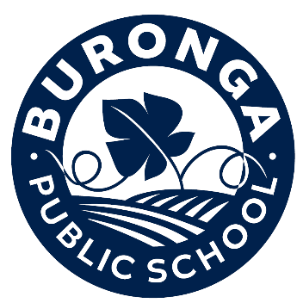
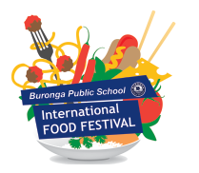

To the interested party,
After such a successful 2023, we are pleased to announce that momentum is again building for the 2024 Buronga Public School International Food Festival to be held on Saturday 16th November from 5-8pm. Last year was an absolutely amazing turnout, with most food vendors selling out within 2 hours!
We are again seeking expressions of interest from any food vendors and/or community groups that may like to take part in this event.
There are limited spaces available so please make your interest known as soon as possible.
Please email your interest to burongapublicschool@pandcaffiliate.org.au
Looking forward to providing the community with another great family friendly event.

Name: ...................................................................................................................................
Contact Person/s: ...................................................................................................................................
Contact Details: Phone: ...................................................................................................................................
Email: ...................................................................................................................................
Recipe Country of Origin: ..................................................................................................................................
Food Types provided: ..................................................................................................................................
We look forward to hearing from you,
Thank you!
Buronga Public School P&C Association
1 Chapman Street BURONGA NSW 2739
Email: burongapublicschool@pandcaffiliate.org.au

