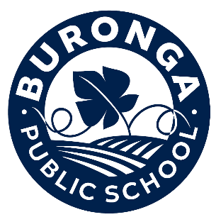
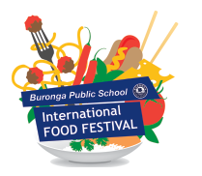

Dear Valued Sponsor,

Thank you to those who participated in the Buronga Public School International Food festival in 2023, we cannot thank you enough. Your support helped make it the resounding success that it was!
We are gearing up once again for this year’s event. It will be held on Saturday 16th November 2024. Our small P&C committee has been running the festival since the 1970s, utilising the vital fundraising that the event generates for the school, the students, and the wider community. After a few years absence, the festival may look a little different, but the focus remains, to provide a family friendly evening including various food stalls, kids’ activities, market stalls, stage entertainment and demonstrations as well as the major raffle.
The festival proceeds will contribute to the schools planned stage three playground upgrades, which will include brand new modern playground equipment, as well as new surfacing and shade structures.
Our Festival could not survive without the generosity of businesses and individuals who kindly provide assistance each year. We therefore ask you to consider sponsorship for the 2024 Food Festival. Any form of assistance or sponsorship is most appreciated. The sponsorship categories are attached and can be made in monetary value or a goods donation that could be included in our major raffle. Raffle books will be on sale throughout the community for at least 4-6 weeks prior to the event which would mean your business and generous donation would receive extensive advertising coverage. If you would like to discuss sponsorship options or matters relating to the festival, please email the P&C using the address below. We can then provide direct contact details to our Executive Committee if required.
The school office can help with contact enquires where necessary.
To maximise your sponsorship and allow time to broadcast your support please respond as soon as possible. We thank you for your time and hope you will be able to assist our school and we especially hope to see you at the festival.
Yours sincerely,
P&C Committee Buronga Public School
1 Chapman Street BURONGA NSW 2739
email: burongapublicschool@pandcaffiliate.org.au

Sponsorship Commitment
Business Name:______________________________________________________________
Contact Name: ______________________________________________________________
Contact Number: _____________________________________________________________
Email address: _______________________________________________________________
I/we wish to provide sponsorship for the Buronga Public School International Food Festival as marked below:

Category of Sponsorship | Amount/prize
PLATINUM Sponsorship $1000 + value
- Signage at our school on Sturt Hwy Fence, for the month of October through until the end of the school year.
- Advertising on the night
- School newsletter advertising opportunities
- 4 x Meal Vouchers
- Newspaper & Radio advertising as Platinum sponsors as well as on our posters and flyers.
- Certificate of Platinum Sponsorship for your business
GOLD Sponsorship $500 - $1000 value
- 2 x Meal vouchers
- Advertising on the night
- Logo in school newsletters
- Certificate of Gold Sponsorship for your business
SILVER Sponsorship - $200 - $500 value
- 2x Meal Vouchers
- Logo displayed on the night.
- Business name listed in school newsletters.
- Certificate of Silver Sponsorship for your business
BRONZE Sponsorship - under $200 value
- Logo displayed on the night.
- Business name listed in school newsletters
- Certificate of Bronze Sponsorship for your business
□ Donation enclosed. □ Please contact to arrange collection.
Signed: _____________________________________________________________________
Print Name: _________________________________________________________________
Please Note: For advertising purposes we will require an electronic copy of your company logo, please email at your earliest convenience to burongapublicschool@pandcaffiliate.org.au

