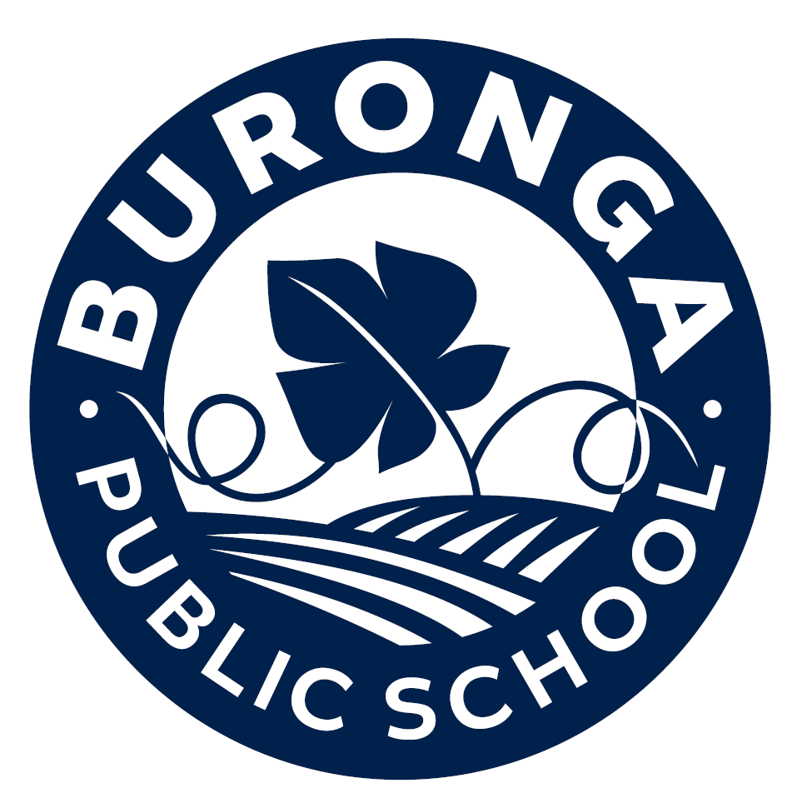
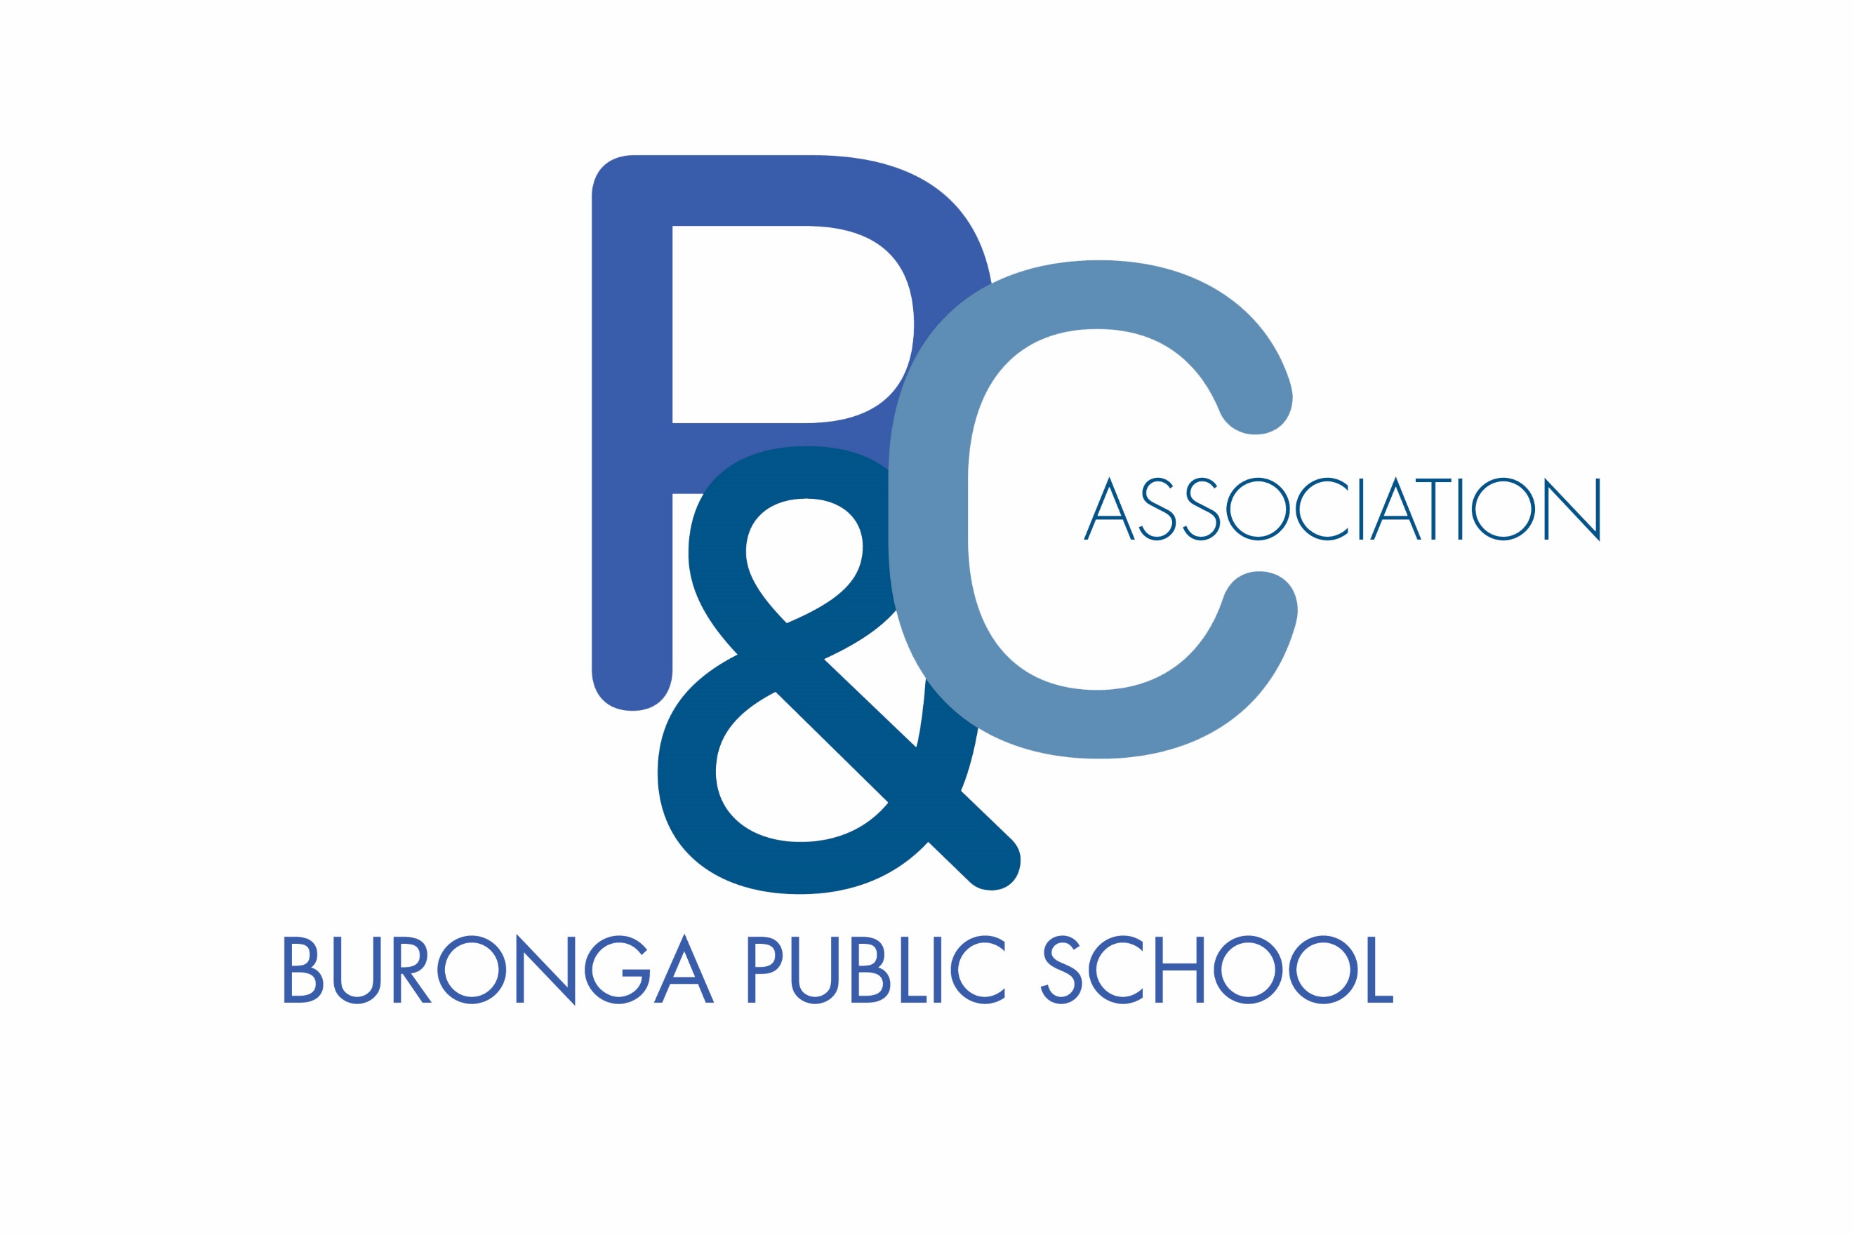

Buronga Public School P&C Association

The Buronga Public School P&C Association is a not-for-profit Organisation which is established to promote the interests of the school by bringing parents, citizens, students, and teaching staff into close cooperation and to assist in providing facilities and equipment for the school and in promoting the recreation and welfare of the students at the school.
Membership of the Buronga Public School P&C Association is open to all parents and guardians of pupils attending the school and to all citizens whose primary residence is in the enrolment area of the school. Buronga Public School P&C Association is always keen to welcome new members.
P&C Association general meetings are held on the 3rd Tuesday of each month at 6pm. Annual membership is $1 and entitles you to be involved in the decision-making of Buronga Public School P&C Association, help with fundraising ideas and other activities that could raise money for the school.
When you become a financial member, you agree to follow the Constitution, by-laws, Code of Conduct and rules, policies and procedures as adopted by the Buronga Public School P&C Association. Copies of these materials are available from the Buronga Public School P&C Association Secretary at each meeting of the P&C Association.
You are recognised as a financial member of the Buronga Public School P&C Association after the meeting closes at which you submit your payment. The Treasurer shall issue you a receipt for this payment, you should retain the receipt for the current P&C Association year as proof of your membership.
If you are interested in becoming a member, please complete the membership Application form and bring it with you to the next meeting of the Buronga Public School P&C Association. If you are unable to attend the next meeting but wish to become a member, please submit this form and payment to the Treasurer via the school front Office.

Buronga Public School P&C Association thanks you for your interest and we hope to see you soon.
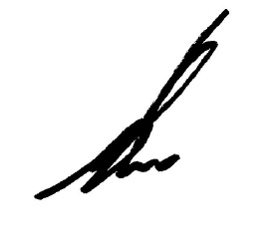
Nick Robertson,
President
nickerobertson@gmail.com
0448239539

